***API Endpoints Details***

| ***API Endpoints:*** | **HTTP Method** | **Uses** |
| --- | --- | --- |
| <http://localhost:8080/demo/> | GET | used for fallBack or landing API |
| <http://localhost:8080/demo/name?firstName=sumit&middleName=kumer&lastName=sahu> | GET | Used to get the full Name using firstName, middleName and lastName. |

1. <http://localhost:8080/demo/>

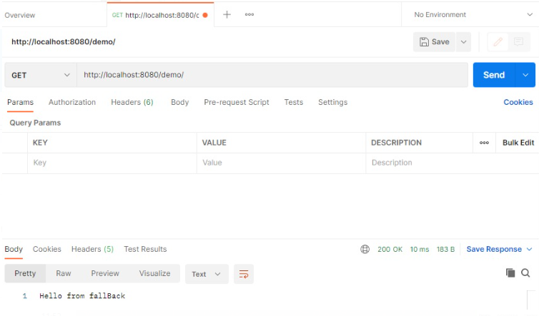

1. <http://localhost:8080/demo/name?firstName=sumit&middleName=kumer&lastName=sahu>

